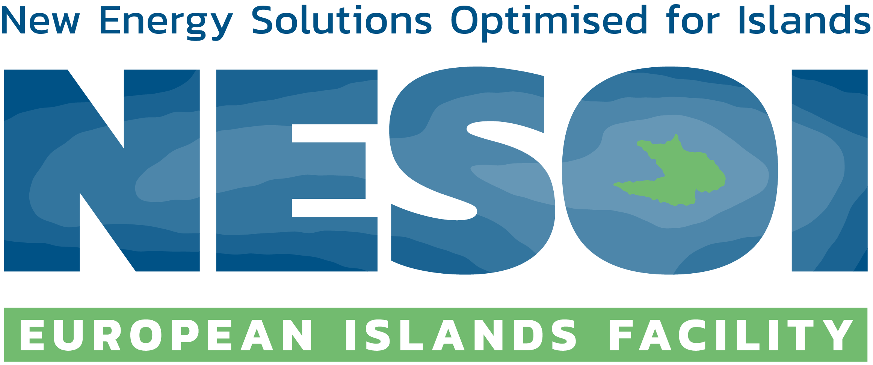

Letter of support to the proposed implementation project
[acronym of the project]

To whom it may concern

I, the undersigned, [Name of legal representative], on behalf of [name of the Competent Authority], confirm our strong support and commitment to the development and implementation of the project [title of the project], led by [legal name of the private company], which will apply to the cascade funding call of the European Islands Facility NESOI.

[name of the Competent Authority] is fully aware of the potential opportunity that the European Islands Facility NESOI brings to unlock the potential of EU islands to become the locomotives of European Energy Transition by providing financial and technical assistance support to develop and implement energy transition investment projects.

Our organisation holds high expectations from this initiative led by [legal name of the private company], which is fully aligned with our energy transition plans. [description of why it is interesting for your organisation]

Yours sincerely,

_________________________________
Signature and Official stamp

[Name of legal representative]
[Position]
[Department]
[Street, No.]
[Postal Code, City, Country]

